Pimoroni Unicorn Hat - 8x8 RGB LED Shield for Raspberry Pi A+/B+

**Fastled Library and Unicorn Hat LED Array Definition (daisy-chained in a serpentine)**

<http://fastled.io/> and <https://github.com/FastLED/FastLED/wiki/Basic-usage>

**leds[i]** Tested empirically with fastled by writing CHSV() values to the positions 0 to 63 into the leds[i] array.

**leds[ XY(x, y)] or leds[ YX(y, x)]** Functions to converts x,y to string position and it is aware of the decoding needed for the serpentine electrical connection.

X (horz.) listed first, Y (vert.) listed second as 0,0 and the origin is in the upper right in this image.

NUM_LEDS = 8 x 8 = 64

MatrixSerpentineLayout = true

Overloaded x values are allowed.

X +

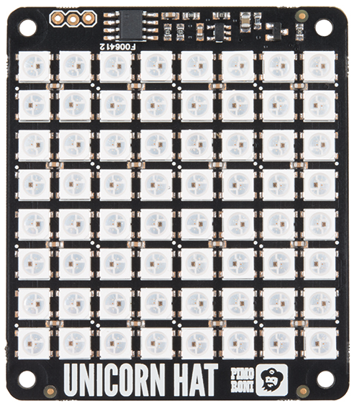

Y +

|  |  |  |  |  |  |  |  |
| --- | --- | --- | --- | --- | --- | --- | --- |
| 7  7,0  7,0 | 6  6,0  6,0 | 5  5,0  5,0 | 4  4,0  4,0 | 3  3,0  3,0 | 2  0,0  2,0 | 1  0,0  1,0 | 0  0,0  0,0 |
| 8  7,1  8,0 | 9  6,1  9,0 | 10 | 11 | 12 | 13 | 14 | 15  0,1  15,0 |
| 23  7,2  23,0 |  |  |  |  |  |  | 16  0,2  16,0 |
| 24  7,3  24,0 |  |  |  |  |  |  | 31  0,3  31,0 |
| 39 |  |  |  |  |  |  | 32 |
| 40 |  |  |  |  |  |  | 47 |
| 55 |  |  |  |  |  |  | 48 |
| 56  7,7  56,0 | 57 | 58 | 59 | 60 | 61 | 62 | 63  0,7  63,0 |

**Core 64 Badge LED Array Installation**

It is **installed in the badge** **rotated 180 degrees**. This keeps the badge width as narrow as possible and the 3 incorrect wires between the LED array and the badge as close as possible. X stays horizontal and Y stays vertical, with the origin in the lower left corner from the user view of the badge.



Y +

|  |  |  |  |  |  |  |  |
| --- | --- | --- | --- | --- | --- | --- | --- |
| 0,7 |  |  |  |  |  |  | 7,7 |
|  |  |  |  |  |  |  |  |
|  |  |  |  |  |  |  |  |
|  |  |  |  | 4,4 |  |  |  |
|  |  |  |  |  |  |  |  |
|  |  |  |  |  |  |  |  |
|  | 1,1 |  |  |  |  |  |  |
| 0,0 |  |  |  |  |  |  | 7,0 |

X +

**Core 64 Badge LED Visual Definition**

To make it easier to work with the layout of arrays in the C language syntax, the logical definition is set to align with the definition of an array in C. Visualizing letters/numbers/symbols is easier this way when writing the program.

**This requires flipping the INSTALLED array across the horizontal axis**.

|  |  |  |  |  |  |  |  |
| --- | --- | --- | --- | --- | --- | --- | --- |
| 0,0 |  |  |  |  |  |  | 7,0 |
|  |  |  |  |  |  |  |  |
|  |  |  |  |  |  |  |  |
|  |  |  |  |  |  |  |  |
|  |  |  |  |  |  |  |  |
|  |  |  |  |  |  |  |  |
|  |  |  |  |  |  |  |  |
| 0,7 |  |  |  |  |  |  | 7,7 |

These are addressed as a C ARRAY in the order of Y (ROW), X (COL)

{0,0,1,1,0,1,1,0}, // heart

{0,1,1,1,1,1,1,1},

{0,1,1,1,1,1,1,1},

{0,1,1,1,1,1,1,1},

{0,0,1,1,1,1,1,0},

{0,0,0,1,1,1,0,0},

{0,0,0,0,1,0,0,0},

{0,0,0,0,0,0,0,0}

Flipping is managed through a Look-Up-Table to make it fast. See the “Code-Control LED Array.docx” document for the implementation.

TECHNICAL DETAILS

Adafruit PRODUCT ID: 2288

<https://www.adafruit.com/product/2288>

<https://shop.pimoroni.com/products/unicorn-hat>

<https://github.com/pimoroni/unicorn-hat>

<https://www.sparkfun.com/products/14037>

3-pin header (as viewed below) left-to right: GND (closest to edge) – DIN (center) – VCC (innermost)

The larger header on the back side is on the right edge as viewed below.

OLD INFO, NOT CORRECT

Spacing of the LED array 6.4mm??? NO

UPDATED WIDTH (across solder pads) MEASURED 1.853/7=.265 in. or 47.17 mm/7= 6.74 mm

UPDATED HEIGHT MEASURED 1.812/7=.259in. or 46.03/7=6.58mm

UPDATED Split the difference to use grid with .262 inches or 6.65 mm

Use Half steps .130 inches

UPDATED Corners of grid center at x/y 7 * .130 = 0.910

Mounting Holes: L-R 1-15/16” U-D 2-9/32”, hole dia .125”

holes at corners X=31/32 (.96875) Y= 1-9/64 (1.140625)

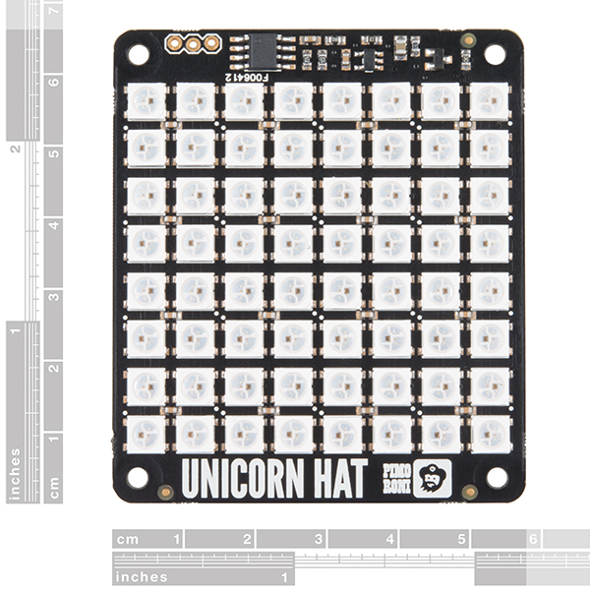

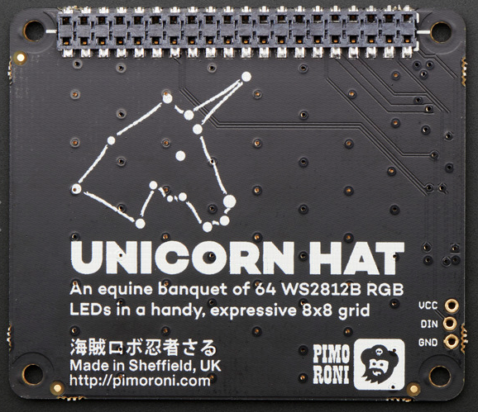

LED SPACING FROM PIMORONI

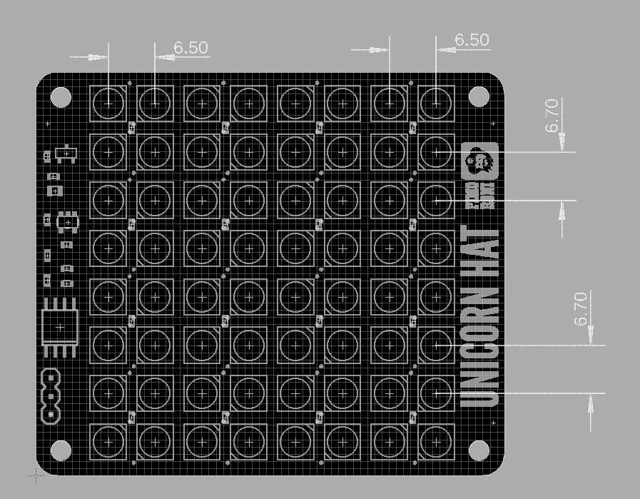

CONFIRMED MARCH 2020:

6.70mm = 0.264 inches

6.50mm = 0.256 inches

65mm x 56mm x 6.5mm / 2.6" x 2.2" x 0.26"

Weight: 20g



# DESCRIPTION

Snap the [Pimoroni](http://shop.pimoroni.com/)**Unicorn Hat** on top of a Raspberry Pi [model A+](https://www.adafruit.com/products/2266) or a [model B+](https://www.adafruit.com/products/1914) for a fun 8x8 RGB LED matrix powered directly from the Pi.

Unicorn HAT provides a wash of controllable color that is ideal for mood-lighting, 8x8 pixel art, persistence of vision effects, status indications, or just blasting colour into your surroundings.

* 64 RGB LEDs (**WS2812B**) each wtih 24-bit RGB color
* Python API (NeoPixel compatible!)
* EEPROM with Raspberry Pi HAT configuration details
* LED data driven via DMA over PWM Pin #18

Experimenting to figure out: Color order: GRB, SerpentineLayout: true

Has a built-in EEPROM for RasPi ID? ST Micro 24c32f s82058 (8-SOIC footprint)

S/N of this board? F006412

# Unicorn HAT

What's going to protect your beloved Raspberry Pi from an onslaught of rainbow-coloured fusion? That's right, it's Unicorn HAT.

Sporting a matrix of 64 (8 x 8) RGB LEDs and powered directly from the Pi, this is the most compact pocket aurora available.

Unicorn HAT provides a wash of controllable colour that is ideal for mood-lighting, 8x8 pixel art, persistence of vision effects, status indications, or just blasting colour into your surroundings.

[The MagPi](https://www.raspberrypi.org/magpi-issues/MagPi42.pdf) said that Unicorn HAT was "one of the coolest HATs around"

## **Features**

* 64 RGB LEDs (WS2812B) which require 3.3 to 5V
* LED data driven via DMA over PWM
* [Unicorn HAT pinout](https://pinout.xyz/pinout/unicorn_hat)
* Compatible with all 40-pin header Raspberry Pi models
* [Python library](https://github.com/pimoroni/unicorn-hat)
* Comes fully assembled

## **Software**

We've put together a [Unicorn HAT Python library](https://github.com/pimoroni/unicorn-hat) to make it a breeze to use, including lots of beautiful examples of what it can do.

## **Notes**

* **Warning**: WS2812 LEDs are bright enough to cause eye pain, do not look at them directly when brightly lit. We recommend the use of a [diffuser](https://shop.pimoroni.com/products/pibow-modification-layers).
* **Photo-sensitivity warning**: flashing, strobing, and patterns of lights may cause epileptic seizures. Always take care and immediately stop using if you feel unwell (dizziness, nausea, affected vision, eye twitching, disorientation).
* **Power**: Unicorn HAT requires a >2A microUSB power supply for your Pi. We recommend [the official Raspberry Pi power supply](http://shop.pimoroni.com/products/raspberry-pi-universal-power-supply).
* **Compatibility (audio)**: as Unicorn HAT uses PWM and GPIO18, it will interfere with analogue audio playback (random colour patterns and flickering). HDMI should work just fine! :D

 PI HEADER IO PINOUT

